CS5404 Homework3

Wei Luo

1. **Brief summary of what you think the project was about.**

This project is about to match the common places of two different pictures. We are trying to match the corners we find in two pictures in order to show that these two pictures have something connection or common.

1. **Brief outline of the algorithmic approach.**

**The HW3.m includes:**

First, we read both two images and translate them to gray images.

Then we use the Harris Corners detector we developed in assignment 2 to these two image to find their corners.

After this, we will get the corresponding patches of these corners. We will compute the matching distance between any two patches in different images.

We will firstly use normalized cross correlation to these patches in order to overcome the possible affine intensity change, and then multiply them together to see how different they are.

If the results are close to 1, it means that the two patches are similar. If A patches in image 1 is most similar of B patches in image 2, and so do B patches. We can get the conclusion that these two patches are best matched.

1. **Pictures of intermediate and final results that convince me that the program does what you think it does.**

Firstly, I find two similar images to test my algorithm.

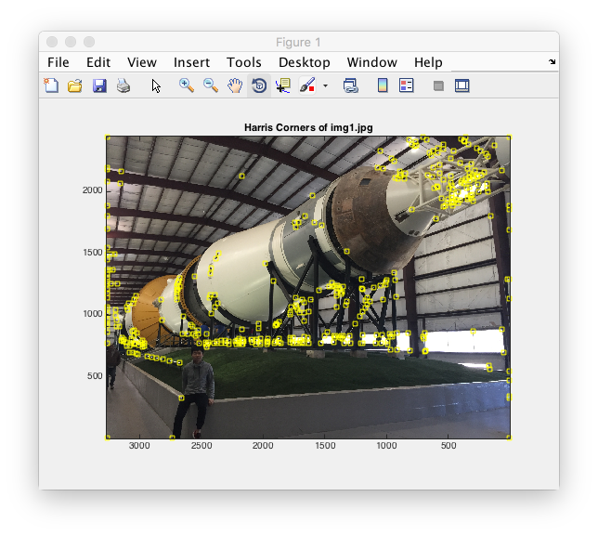

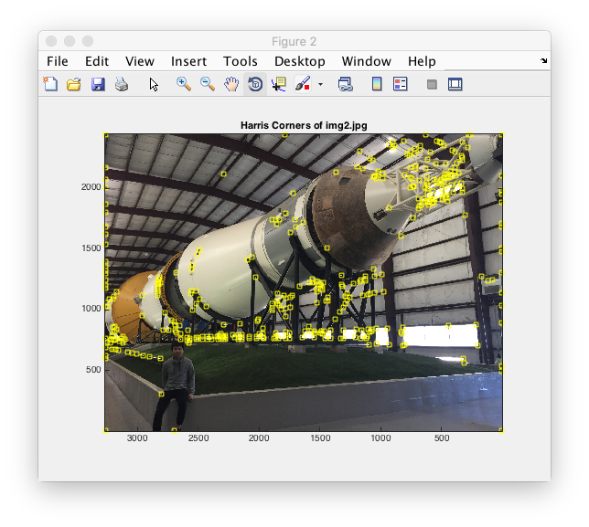

These two images are from the Harris Corners Detector I built. (400 corners each)

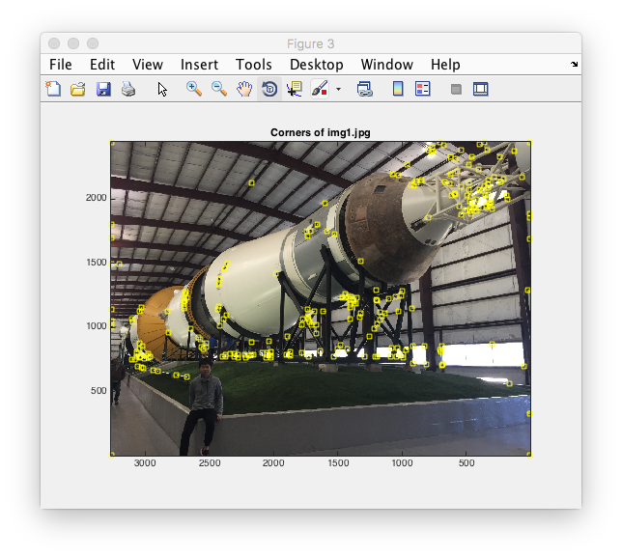

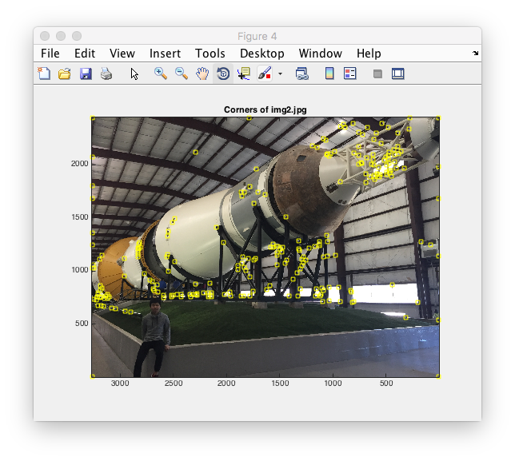

These two images are the rest of corners after matching. And the match result is below.

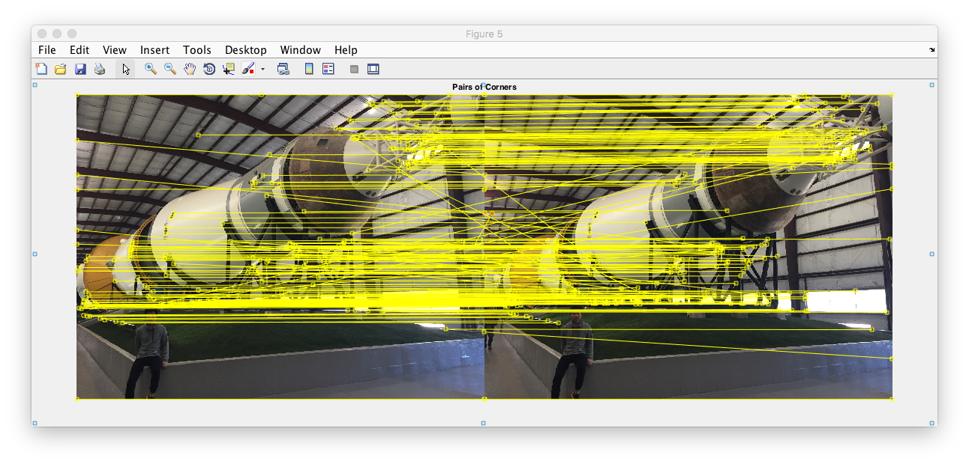

Then, I find two images with similar food (actually not the same) to test.

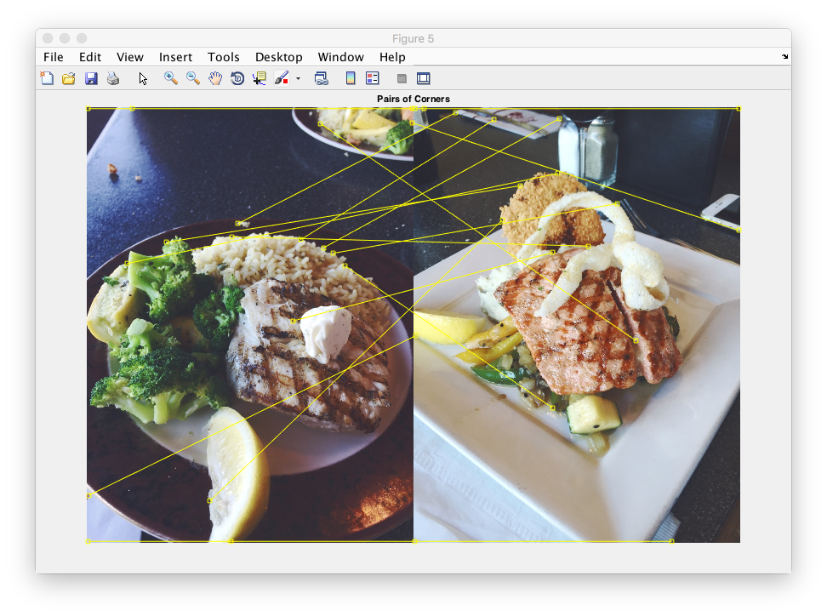

1. **Any design decisions you had to make.**

In the first experiment, I set the sigma S = 2, size of local neighborhood N = 7, radius of neighbor D = 200. Because the common places of these two images are large and it is better to make them smooth before detector, so that we can get more corners in different area of the image. Besides, the size of patches I set is 11, and the threshold in corner match I set is 0.8. This threshold is to limit the distance of two patches, it cannot lower than this value.

Without bidirectional matching, we have 400 corners each image, after that we have 246 corners left. The results is showed above.

In the second experiment, I set the size of patches is 23, and the threshold is 0.9. Before bidirectional matching, we have 200 corners each image.

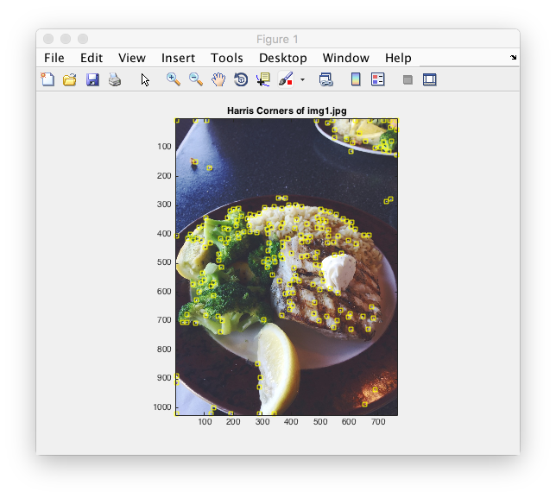

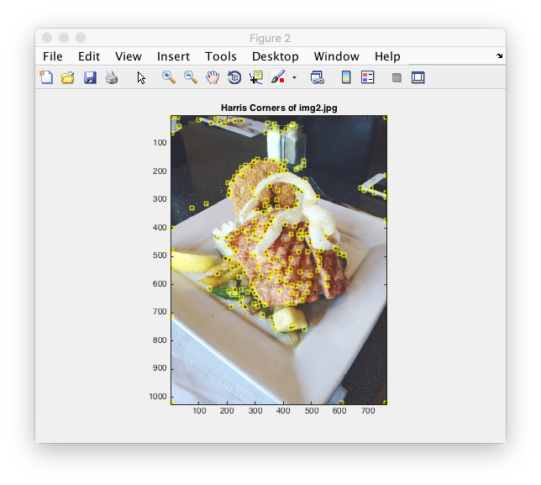

After bidirectional matching, we only have 18 corners match.

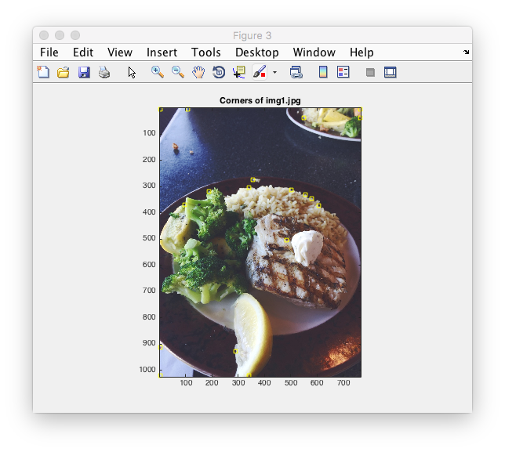

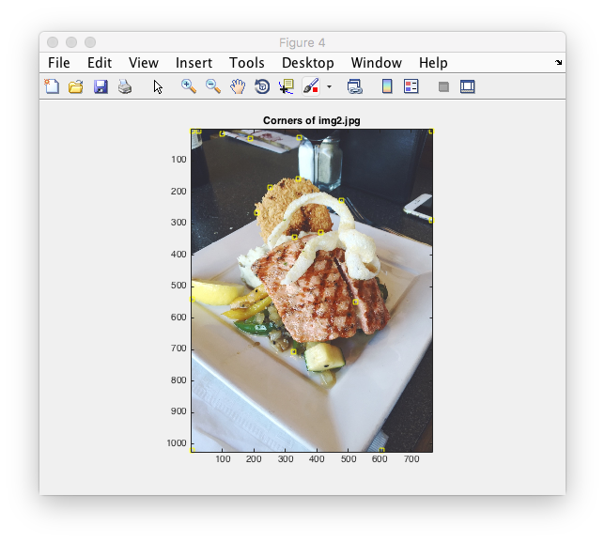

1. Experimental observations.

From these two experiment I tried, it is obviously that the result of bidirectional matching of two images is good. Even though there are still some corners from different features match. I am satisfying with the results. I believe that in the next step, we can still recognize these different features.

Besides, I try my set in experiment 2 into experiment 1.





These two images are from the Harris Corners Detector I built. (400 corners each)

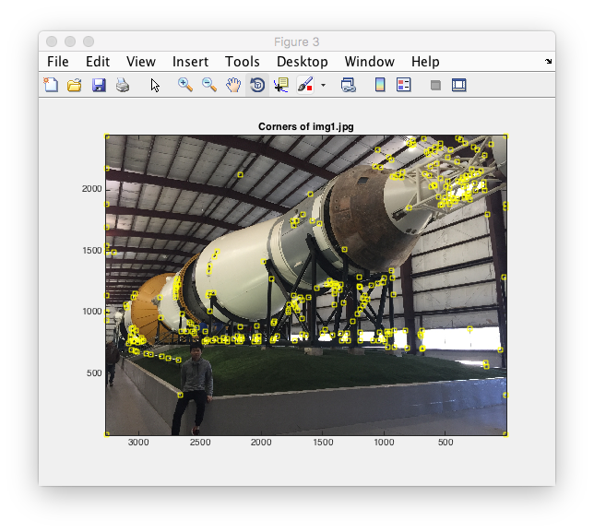

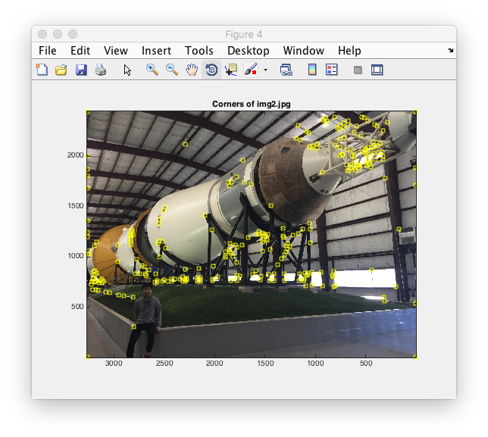

These two images are the rest of corners after matching. And the match result is below.

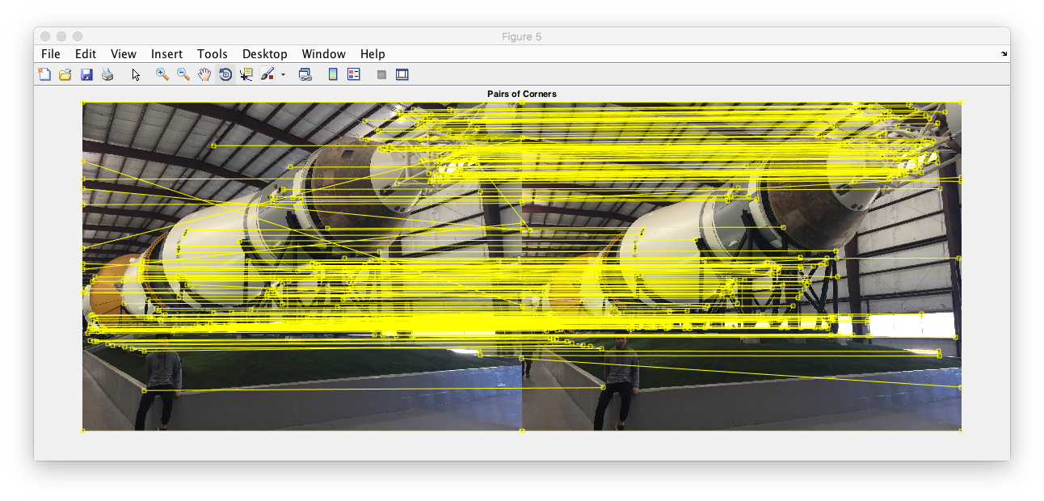

These time we got 276 match corners of each image. Even the limit is higher, but the result is better.